**New York University Tandon School of Engineering**

Biomedical Engineering

Applied Mathematics and Statistics for Biomedical Engineering

Fall 2020

Professor Mirella Altoe

Tuesday 5:00-7:30PM Rogers Hall 325

# Computer Lab Assignment #4

**QUESTION 1:** Juvenile long-tailed tits (*Aegithalos caudatus*), a European relative of the chickadee, “help” adult birds raise offspring, such as by feeding their nestlings. What is the evolutionary advantage of helping behavior: practice for parenthood; increased changes of inheriting the adults’ territory in future; or indirect genetic benefits via increased success of kin? To investigate, Russell and Hatchwell (2001) monitored the behavior of 17 juveniles, each of which lived equidistant from two nests of adult birds. In each case, one nest was parented by a **relative of the helper**, and the other was parented by **non-kin adults**. Sixteen of the juveniles helped at the nest of their kin, whereas one helped at the non-kin nest. Do these results provide evidence for preferential helping at the nests of kin? Conduct the appropriate test.

1. **(0.50 pts.) Clearly state an appropriate null hypothesis and an alternative hypothesis.**

H0: Juvenile long-tailed tits do not display behavior of preferential helping towards nest of kin.

HA: Juvenile long-tailed tits do display behavior of preferential helping towards nests of kin.

1. **(0.50 pts.) Do these results provide evidence for preferential helping at the nests of kin? Conduct the appropriate test.**

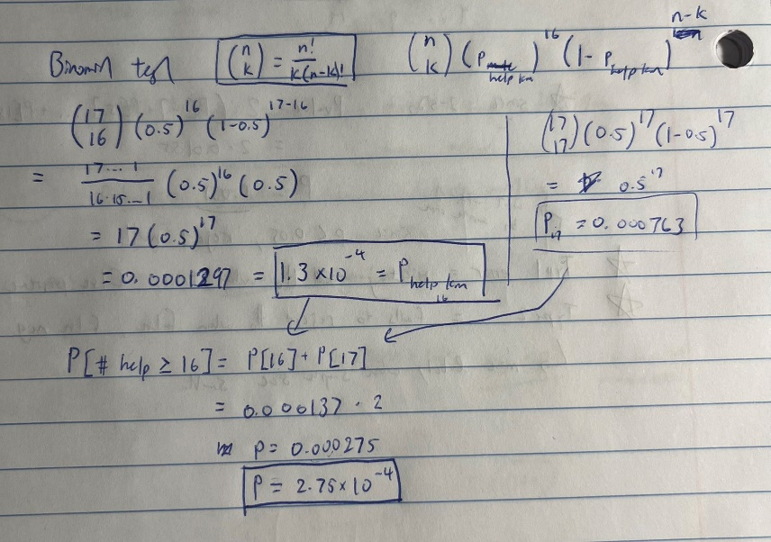

The p value is significantly below the conventional threshold of p < 0.05. Thus, we reject the null hypothesis and accept the alternative.

**QUESTION 2:** Each member of a large genetics class grows 12 pea plants from an independent pea family. Each family is expected to have 3/4 plants with smooth peas and 1/4 plants with wrinkled peas.

1. **(0.50 pts.) On average, how many wrinkled pea plants will a student see in her 12 plants?**

Three wrinkled pea plants are expected.

1. **(0.25 pts.) What is the standard deviation of the proportion of wrinkled pea plants per student?**

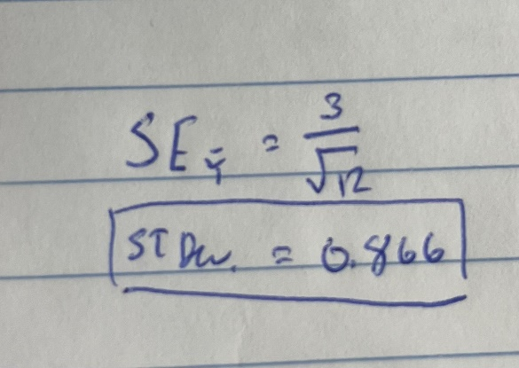

1. **(0.25 pts.) What is the variance of the proportion of wrinkled pea plants per student?**

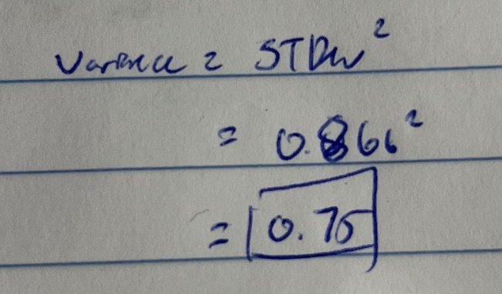

1. **(0.50 pts.)** Predict what proportion of the students saw exactly two wrinkled pea plants in their sample.

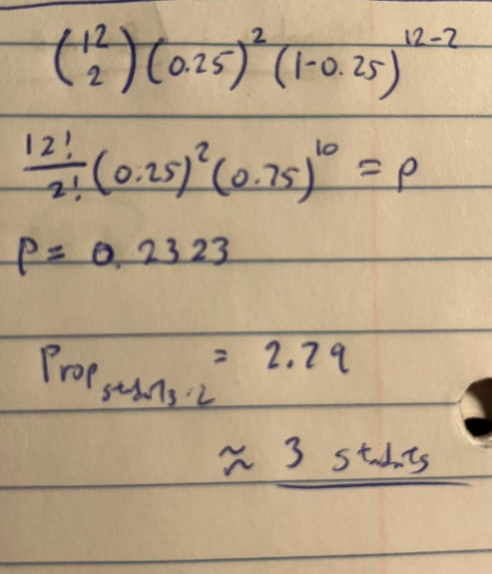

**QUESTION 3:** In North America, between 100 million and 1 billion birds die each year by crashing into windows on buildings, more than any other human-related cause. This figure represents up to 5% of all birds in the area. One possible solution is to construct windows angled downward slightly, so that they reflect the ground rather than an image of the sky to a flying bird. An experiment by Klem et al. (2004) compared the number of birds that died as a result of vertical windows, windows angled 20 degrees off vertical, and windows angled 40 degrees off vertical. The angles were randomly assigned with equal probability to six windows and changed daily; assume for this exercise that windows and window locations were identical in every respect except angle. Over the course of the experiment, 30 birds were killed by windows in the vertical orientation, 15 were killed by windows set at 20 degrees off vertical, and 8 were killed by windows set at 40 degrees off vertical.

1. **(0.50 pts.)** Clearly state an appropriate null hypothesis and an alternative hypothesis.
2. **(0.25 pts.)** What proportion of deaths occurred while the windows were set at a vertical orientation?
3. **(0.25 pts.)** What statistical test would you use to test the null hypothesis?
4. **(0.50 pts.)** Carry out the statistical test from part (c). Is there evidence that window angle affects the mortality rates of birds?